**How to completely remove printer**

**Contents**

1. Info 2

2. Default remove 2

3. Remove printer from Print management 2

4. Remove printer from Print Server Properties 3

5. Clear spooler and printer queue 3

6. How to disable Automatic printer install 4

7. Clean printer from the registry 4

8. Delete print processor from registry 5

# Info

*Version 0.2а, 2021.07.23*

# Default remove

Open Control Panel, Devices, right click the printer and remove it.

Or

Open Setting, Devices, Printers and scanners, click the printer and remove it.

# Remove printer from Print management

Open Print Management as Administrator, go to Print Management, All printer and delete the printer.

Open Print Management as Administrator, go to All Drivers, select the drive, press right click, then press Remove Driver Package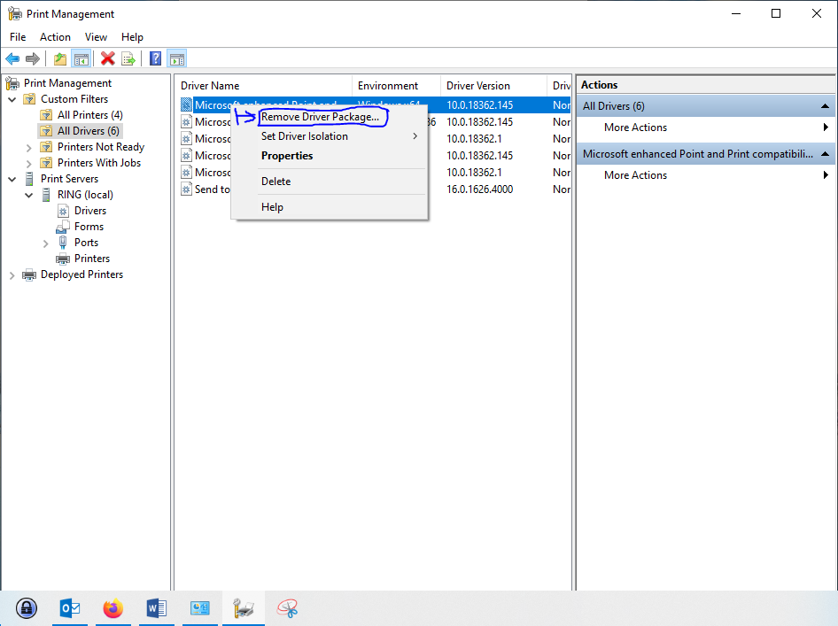

You will see this windows:

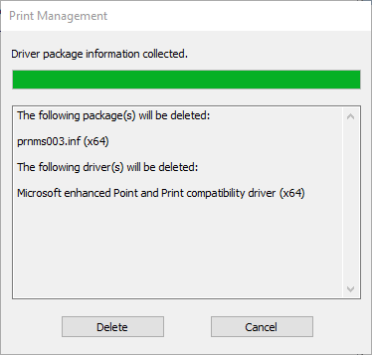

Don’t press Delete!   
Now open Services as Administrator, go to Print Spooler and stop it.   
After that start the Print Spooler and immediately go to the Print Management and now press Delete. (stop and start is preferred than restart)

# Remove printer from Print Server Properties

Open run, type “printui /s /t2” and press enter.  
Enter your credentials to open as Administrator.  
Go to Drivers, select the driver, Remove, Remove driver and driver package.

# Clear spooler and printer queue

Open Services as Administrator, stop Print spooler.  
Open in file explorer ‘C:\Windows\System32\Spool\Printer’ and delete all files in the folder.  
Open Services as Administrator, start Print spooler.

# How to disable Automatic printer install

Open File Explorer, right click This PC > Properties  
Advanced system settings  
Hardware  
Device installation settings  
Do you want to download driver software and realistic icons for your devices? > No…

Save changes.

# Clean printer from the registry

* 1. Stop Spooler service.
  2. Start registry editor (regedit) as administrator.

If you cannot edit registries even as administrator download PSExec and load regedit though it.

**psexec -s -i regedit.exe**

* 1. Go to the

**HKEY_LOCAL_MACHINE\SYSTEM\CurrentControlSet\Control\Print\Environments\Windows NT x86DriversVersion-4**

Or

**HKEY_LOCAL_MACHINE\SYSTEM\CurrentControlSet\Control\Print\Environments\Windows x64\Drivers\Version-4**

* 1. And delete the drivers. Also go to the

**Computer\HKEY_LOCAL_MACHINE\SYSTEM\CurrentControlSet\Control\Print\Printers**

* 1. And delete the printer.

**HKLM\SOFTWARE\Wow6432Node\Microsoft\Windows NT\CurrentVersion\Print\Providers\Client Side Rendering Print Provider\User SID\Printers\Connections\Printer name**

**HKLM\SOFTWARE\Wow6432Node\Microsoft\Windows NT\CurrentVersion\Print\Providers\Client Side Rendering Print Provider\Servers\Print server FQDN\Printers\{GUID}**

**HKEY_LOCAL_MACHINE\SOFTWARE\WOW6432Node\Microsoft\Windows NT\CurrentVersion\Print\Printers**

**HKEY_LOCAL_MACHINE\SYSTEM\CurrentControlSet\Control\Print\Providers\ LanMan Print Services\Servers\\Printers\**

# 8. Delete print processor from registry

If you cannot remove the printer because of print processor is used.

1. Stop print spooler.
2. Open Regestry.
3. Go to

**Computer\HKEY_LOCAL_MACHINE\SYSTEM\CurrentControlSet\Control\Print\Environments\Windows x64\Print Processors**

1. **Rename the processor with .old and start print spooler service.**
2. **Try to delete the printer now.**